Memo
To: Philip Dimmock
CC: Arjan Schouten-Netten
From: Harry Brandsen
Date: 06/JAN/2006
Re: BILABRI-DX1 OPS

Correction of density log

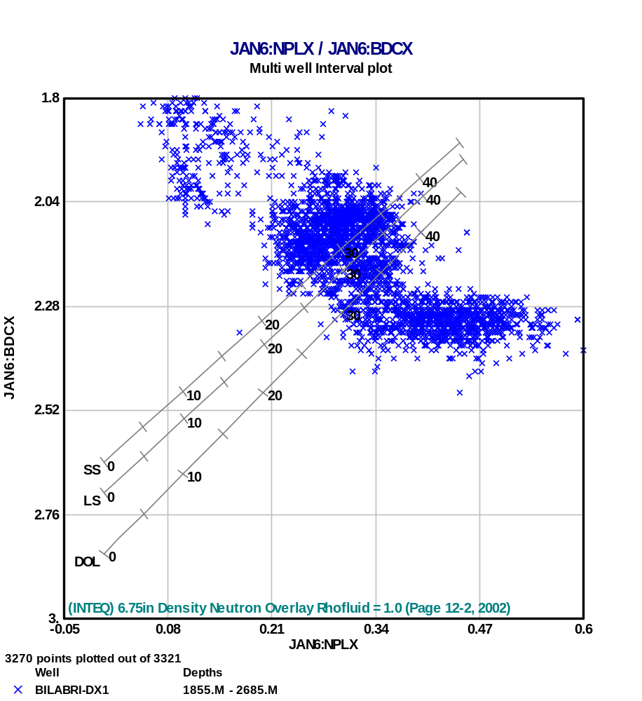
From the neutron/density cross-plot for the interval 1855-2685 is show in Figure 1, the gas sands can clearly be seen. However, a significant number of data-points plot above the sand-line, indicating that the density reads too low. Therefore a bulk shift of 0.12g/cc was applied to the density, resulting in a more reliable distribution of data points on the neutron/density cross-plot (see Figure 2).
Gas sands
These points plot above the sand line, but are water-bearing!

Figure 1: neutron/density plot Bilabri-DX1 (1855-2685m md)

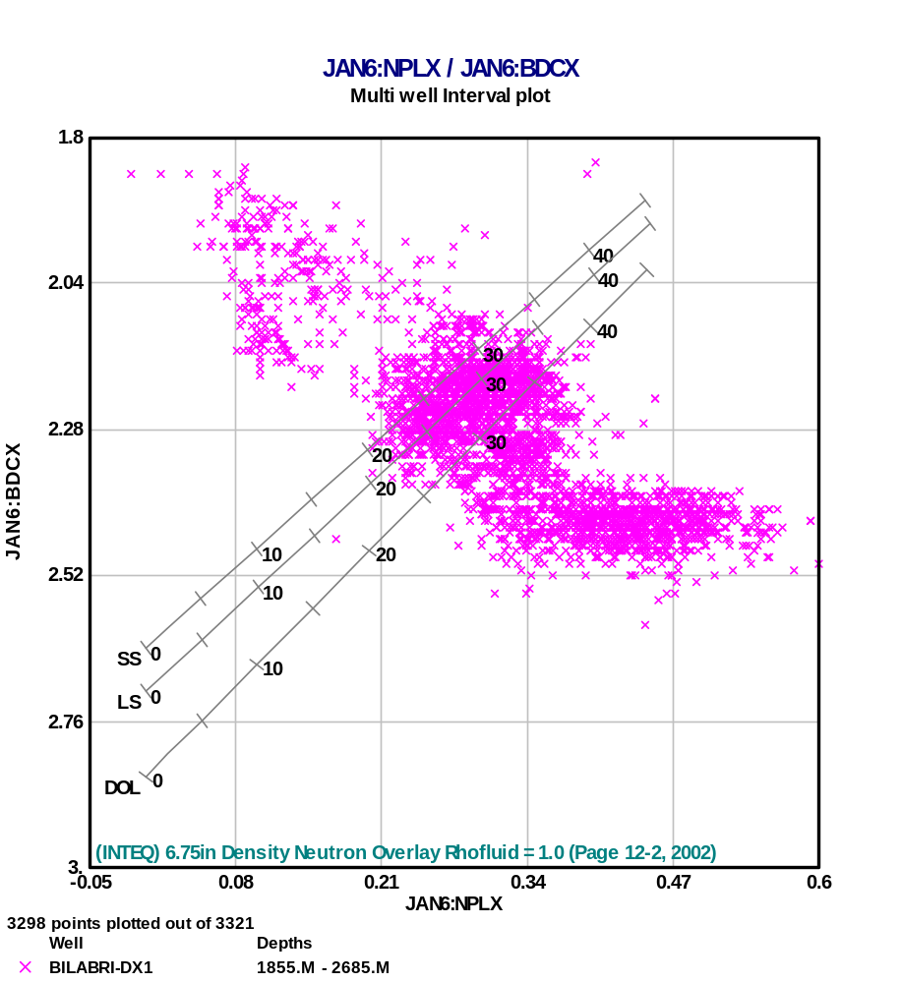

Figure 2: neutron/density plot Bilabri-DX1, plotting the corrected density.

The low readings of the density could possibly be due to the deviation of the borehole; if the ultimate density log has been obtained from combining the different quadrants on the tool, or using not the quadrant facing the formation, the readings will probably be too low. It is recommended to check the individual channels to resolve this.

Gas correction/fluid densities

A fluid density log was created in order to correct the density-porosity calculation for the gas effect. Using an estimated gas-pressure of 3500psia, and a reservoir temperature of 175°F the in-situ gas density used was calculated ~0.20g/cc. For the oil-leg 0.8 g/cc was used, whereas a density of 1 g/cc for the water-bearing zones was assumed.

Name | Interval |  | Gross thickness | Fluid | Fluid density used
 | Top [m md] | bottom [m md] | [m |  | [g/cc]
UGS | 1886.75 | 1895.25 | 8.5 | ?Gas | 0.2
MGS | 2430.50 | 2460.25 | 29.75 | Gas | 0.2
OS-GAS | 2505.75 | 2534.25 | 28.5 | Gas | 0.2
OS-OIL | 2534.25 | 2561.50 | 27.25 | Oil | 0.8
Table 1: Fluid distribution and fluid densities used. Everywhere else, the fluid density was set to 1.

Shale volume

The shale volume was calculated using the GR and the linear shale volume equation:

Vshgr = (GR-GR_{cl-sst})/(GR_{shale}-GR_{cl-sst})

Porosity calculation

(Total) Porosity was subsequently calculated using the classic equation:

Phit=(RHOm-RHOb)/(RHOm-RHOf)

The ‘MGS’ and ‘OS’ are both clean sands. Hence the total and effective porosities are approximately equal. In the ‘UGS’ however, the GR reads higher, which most likely indicate shaliness. However, radioactive minerals such a glauconite and mica will have a similar effect on the GR. In general, immature sediment will have an effect on RHOm, and thus on porosity. To correctly assess this, detailed cutting descriptions, and samples (if available) should be checked. As at the moment of this quicklook evaluation no such descriptions were available, a matrix density of 2.65 g/cc (i.e. quartz) was assumed, and a shale volume was calculated using the GR log. The shales were found to have approximately 0.14 porosity. The effective porosity then follows:

Phif=Phit-0.14*Vsh

Formation water resistivity

No information on the formation water salinity/resistivity was available, but the apparent formation resistivity was estimated from the clean, water-bearing sands around 2000m by using Archie’s equation reworked into;

Swn = 1n = 1 = (a*Rwa)/(Rt*Phim) → Rwa = Rt * Phim

There are 2 unknowns in this equation; Rw and m. In order to derive Rw, m is estimated 1.8, hence follows Rwa (~0.1 ohmm at Tres, which translated into formation water salinity of around 27-28 kppm. Salinity was assumed constant over the reservoir section. Rwa was kept constant over the reservoir section, due to the limited effect of temperature (10°F or 0.01ohmm), although sensu-strictu not right with constant salinity. However, varying salinity with depth will have a far greater effect on Rwa!

Saturation
Saturation was calculated using a simple Archie equation with the following parameters:

a = 1
m = 1.8
n = 1.9
Rwa = 0.1 ohm @ res

Note that the method does not take into account the affect of shale. However, the lower reservoir units largely comprise rather clean sandstones, hence the clay will have a limited effect on the saturations calculated.

Summary of petrophysical properties

A quicklook summary of petrophysical properties is presented below. The following cut-offs were applied:

Net reservoir: Vsh>=0.5 and Phie>=0.02 (to filter out noise)
Net pay: Vsh>=0.5, Phie>=0.02 and Sw<=0.5

NET RESERVOIR ROCK SUMMARY

Zone | Top | Bottom | Gross | Net | N/G | Av Phi | Av Sw | Av Vcl | Phi*H | Phi*So*H
 | TVD/TVT | TVD/TVT | TVD/TVT | TVD/TVT | TVD/TVT |  |  |  | TVD/TVT | TVD/TVT
UGS | 1886.75 | 1895.25 | 8.5 | 5.25 | 0.618 | 0.157 | 1 | 0.335 | 0.713 | 0
 | 1873.97 | 1881.3 | 7.33 | 4.53 | 0.618
MGS | 2430.5 | 2460.25 | 29.75 | 22.75 | 0.765 | 0.258 | 0.163 | 0.196 | 4.929 | 4.127
 | 2328.19 | 2353.16 | 24.97 | 19.1 | 0.765
OS-GAS | 2505.75 | 2534.25 | 28.5 | 28.13 | 0.987 | 0.227 | 0.177 | 0.142 | 5.355 | 4.407
 | 2391.34 | 2415.28 | 23.94 | 23.63 | 0.987
OS-OIL | 2534.25 | 2561.5 | 27.25 | 20.88 | 0.766 | 0.206 | 0.386 | 0.234 | 3.598 | 2.209
 | 2415.28 | 2438.11 | 22.83 | 17.5 | 0.766
All Zones | 1886.75 | 2561.5 | 94 | 77 | 0.819 | 0.225 | 0.264 | 0.196 | 14.594 | 10.744
 | 2415.28 | 2438.11 | 79.07 | 64.75 | 0.819

NET PAY ROCK SUMMARY

Zone | Top | Bottom | Gross | Net | N/G | Av Phi | Av Sw | Av Vcl | Phi*H | Phi*So*H
 | TVD/TVT | TVD/TVT | TVD/TVT | TVD/TVT | TVD/TVT |  |  |  | TVD/TVT | TVD/TVT
UGS | 1886.75 | 1895.25 | 8.5 | 0 | 0 | 0.157 | 1 | 0 | 0 | 0
 | 1873.97 | 1881.3 | 7.33 | 0 | 0
MGS | 2430.5 | 2460.25 | 29.75 | 21.75 | 0.731 | 0.261 | 0.14 | 0.192 | 4.774 | 4.103
 | 2328.19 | 2353.16 | 24.97 | 18.26 | 0.731
OS-GAS | 2505.75 | 2534.25 | 28.5 | 27.63 | 0.969 | 0.227 | 0.169 | 0.138 | 5.269 | 4.379
 | 2391.34 | 2415.28 | 23.94 | 23.21 | 0.969
OS-OIL | 2534.25 | 2561.5 | 27.25 | 14.63 | 0.537 | 0.228 | 0.287 | 0.182 | 2.792 | 1.99
 | 2415.28 | 2438.11 | 22.83 | 12.27 | 0.537
All Zones | 1886.75 | 2561.5 | 94 | 64 | 0.681 | 0.225 | 0.184 | 0.166 | 12.835 | 10.473
 | 2415.28 | 2438.11 | 79.07 | 53.73 | 0.68

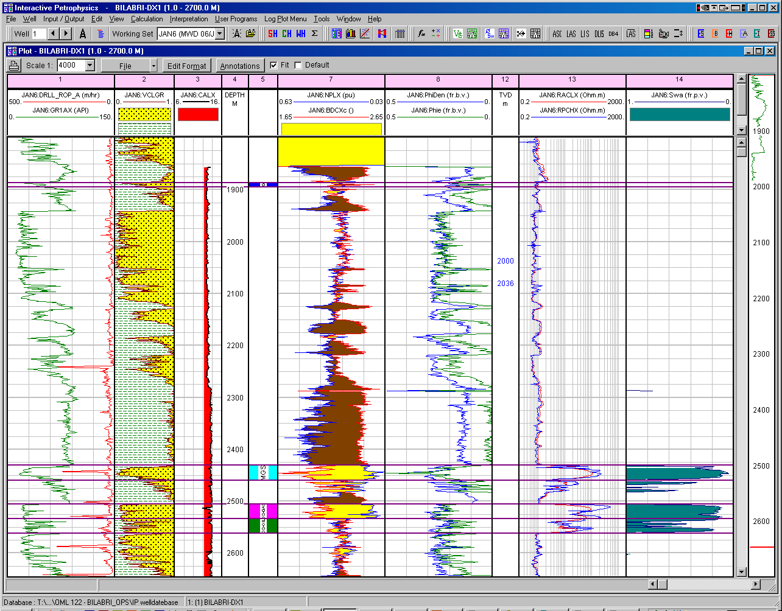
Figure 3: Overview Bilabri-DX1 MWD logs and quicklook evaluation.
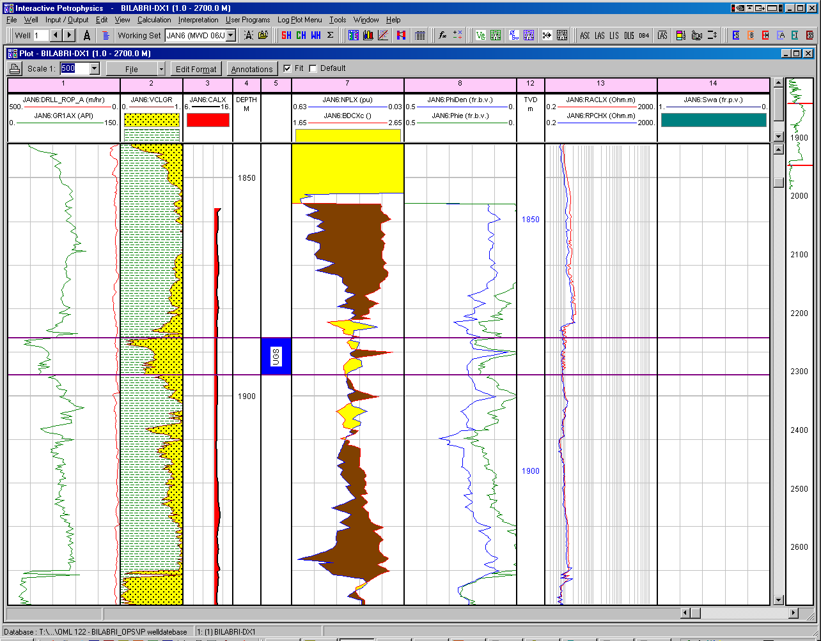
Figure 4: Detail UGS. This unit is most likely water-bearing, see logs and interpretation.
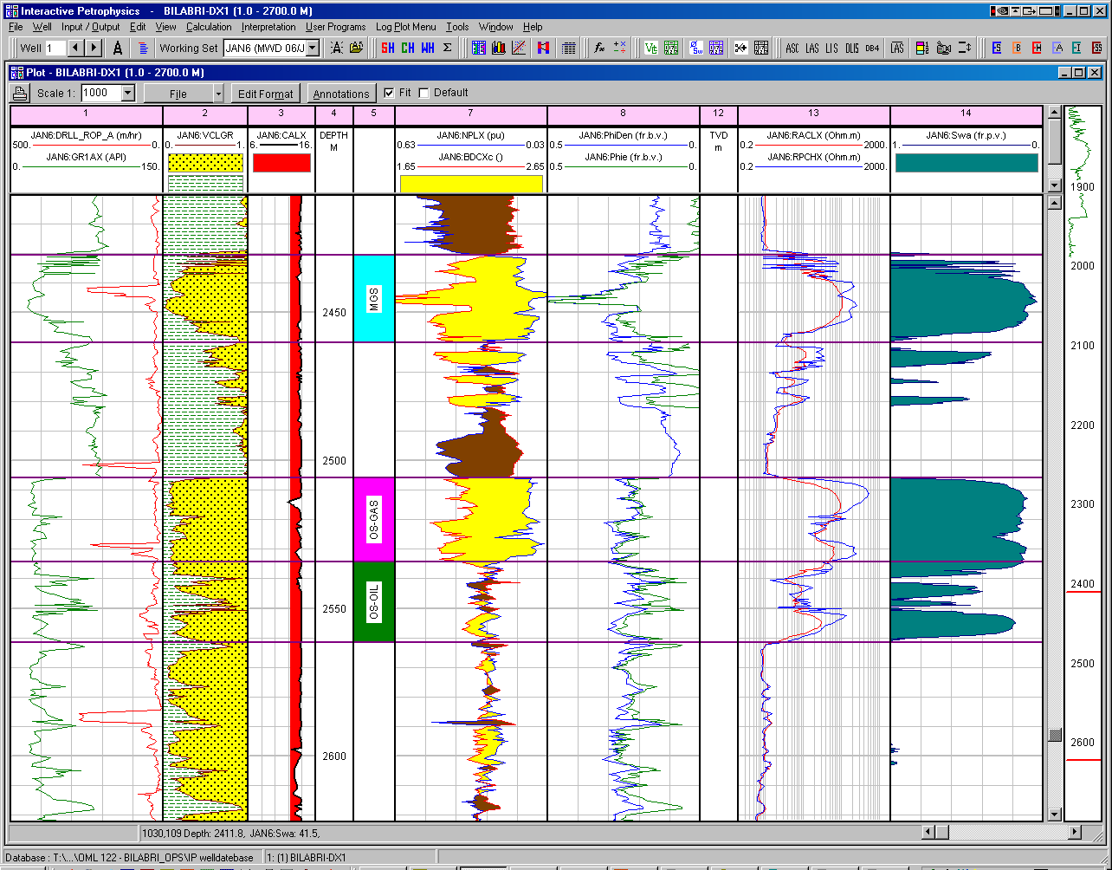
OIL
GAS
Figure 5: Detail of MGS and OS units.

